Please follow below Steps:

1. Open a Master ticket
2. Ctrl + F : Related Items and click on the “+” Sign

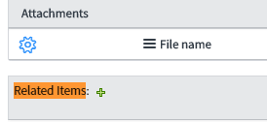

1. Add Appropriate filter as per the Incident and click Run Filter Button, the incidents will be populated in the Available tasks column.

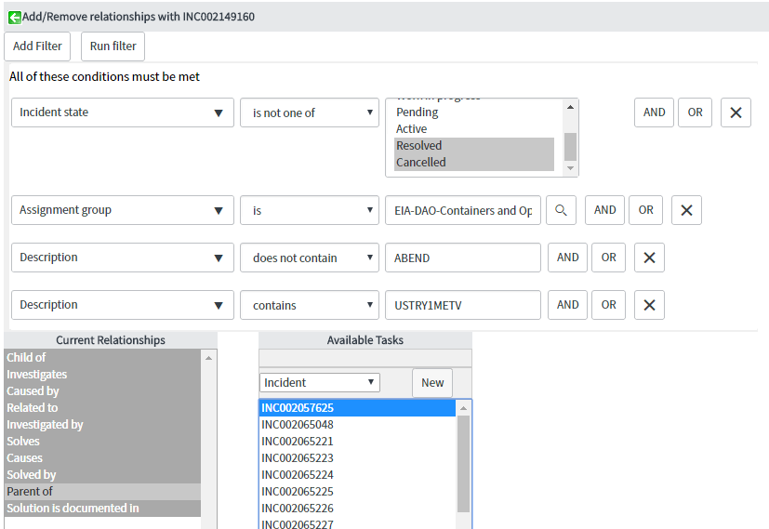

1. Click on **Parent Of** in the **Current Relationships** column and select all the populated incidents. Click on the Add Arrow button.

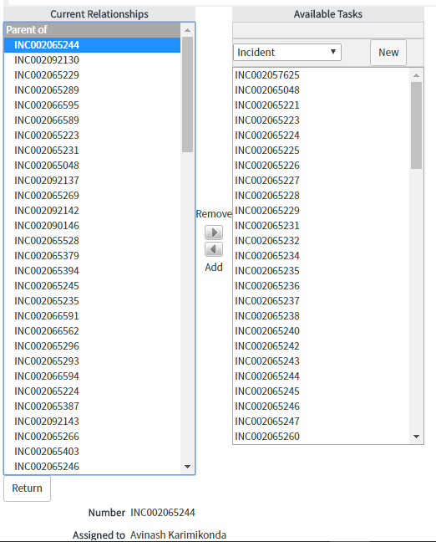

1. Click on the Green Arrow on the top, to add the tickets selected in above step.

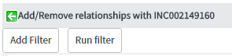

1. We can now see that the tickets are related. Now resolve the parent ticket with appropriate comments and all the child tickets will get resolved. You can relate max 100 tickets to a parent incident.